**Things to consider before the start of the project:**

* C# env in visual studio code
* ESP32 like microcontroller
* Influxdb in the docker desktop

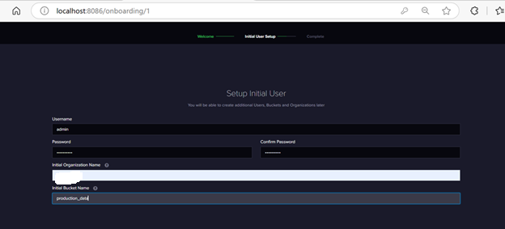

Admin (mypwd)

admin token of the INFLUXDB: (Copy to Clipboard

xxxxxxxxxxxxxxxxxxxxxxx==

Organization - Sabhya

Bucket – production_data

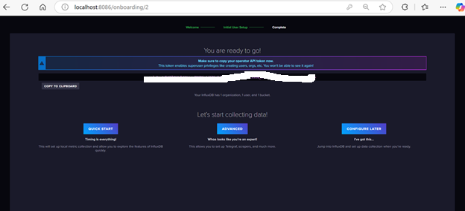

Quickstart

Buckets

Connect the ESP32 microcontroller

Use device manager to know the port

Use that in C# code – here it is COM5

Set the influxDB Settings  
with admin influx token, org and bucket name.

Run the c# code through command line:Make sure the installation of the packages is done.

Example-- dotnet add package InfluxDB.Client

In influxdb run the following in the query builder:

from(bucket: "2ESPSC")

|> range(start: -24h)

|> filter(fn: (r) => r._measurement == "task_status")

See the histogram

